**User Documentation**

Thank you very much for taking the time to complete our user experiment!

We recommend that you set aside approximately 1 hour of free time to start the experiment by reading this user document. If you have any interruptions, we suggest pausing the answering process after completing each major section and resuming when you have time. Please note: Do not close the webpage in the meantime, as the information will not be saved. Thank you!

Next, I will introduce to you from three aspects so that you can better understand and conduct the experiment.

1. **Experiment Composition**

We used three datasets, including:

|  |  |  |
| --- | --- | --- |
| Southern Women | DBLP | Co-Author Network |
| recorded the social interactions of 18 women during 14 informal social activities over a period of 9 months | recorded the collaborative relationships among 70 authors in 30 journal papers | recorded the collaborative relationships among 114 authors in academic publications. |

The experiment is divided into seven parts:

The first part is the background information, which aims to understand your age, gender, major, and familiarity with visualization.

The second part is "Experiment 1" consisting of 6 questions. The first three questions correspond to one dataset each, while the following three questions ask you to evaluate the difficulty, completion speed, and accuracy of your responses in Experiment 1. The first three questions of Experiment 1 explore concavity, which we will explain to you in detail later.

The third part is "Experiment 2" consisting of 6 questions. The first three questions correspond to one dataset each, while the following three questions ask you to evaluate the difficulty, completion speed, and accuracy of your responses in Experiment 2. The first three questions of Experiment 2 explore flatness, which we will explain to you in detail later.

The fourth part is "Experiment 3" consisting of 6 questions. The first three questions correspond to one dataset each, while the following three questions ask you to evaluate the difficulty, completion speed, and accuracy of your responses in Experiment 3. The first three questions of Experiment 3 explore coverage, which we will explain to you in detail later.

The fifth part is "Experiment 4" consisting of 6 questions. The first three questions consist of two questions each for one dataset, while the following three questions ask you to evaluate the difficulty, completion speed, and accuracy of your responses in Experiment 4. The first three questions of Experiment 4 explore the uniformity of distances between nodes, which we will explain to you in detail later.

The sixth part is "Experiment 5" consisting of 39 questions. The first 12 questions, labeled as "Experiment 5-1-1" to "Experiment 5-1-12", correspond to the first dataset. The middle 12 questions, labeled as "Experiment 5-2-1" to "Experiment 5-2-12", correspond to the second dataset. The last 12 questions, labeled as "Experiment 5-3-1" to "Experiment 5-3-12", correspond to the third dataset. The final 3 questions ask you to evaluate the difficulty, completion speed, and accuracy of your responses in Experiment 5. The first 36 questions of Experiment 5 aim to explore users' cognitive abilities regarding data categories, which we will explain to you in detail later.

The seventh part is a questionnaire, consisting of 9 questions. Questions 1 to 3 correspond to each dataset, and we would like you to rank them based on your preference. Questions 4 to 8 ask users about the importance of various evaluation factors. Question 9 asks users to provide any other factors they were paying attention to in the hypergraph during the experiment.

1. **Introdution**

2.1 What is a hypergraph?

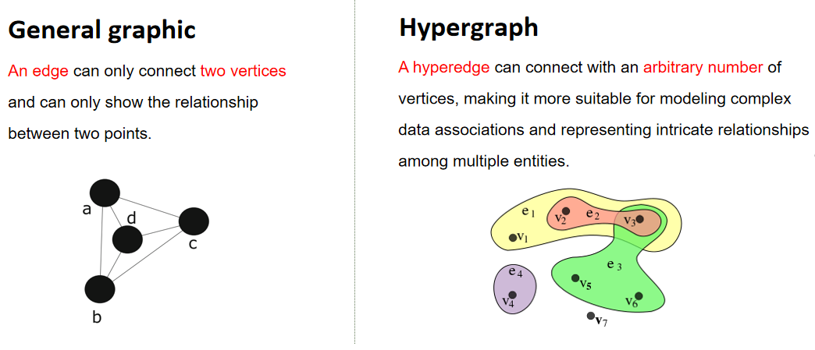

What you need to note is that determining whether a point belongs to a hyperedge requires checking if the point is entirely within that hyperedge. In the given partial hypergraph depicted in the image, are PA and SA within the same hyperedge in the red circle? The answer is no, this is because if SA were also part of the brown hyperedge, the area where SA is located would protrude towards the lower left, fully encompassing SA. This follows the rule of the hypergraph drawing algorithm.

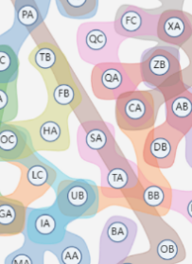

2.2 What are the benefits of hypergraphs?

* The display effect is more intuitive and easy to understand.
* More accurately express complex relationships.
* Easy long-term maintenance and updates.

2.3 There is an example of using hypergraphs!

Use hypergraph to represent the relationship between characters and chapters in the work.

This method can reveal some interesting information and patterns in Les Miserables, such as:

【Vertex 1】Jean Valjean is a crucial vertex in the hypergraph. He has the most connections with other vertices and is the only one that appears in all scenes.

【Vertex 1 and 2】Judge Javert is Jean Valjean's most formidable enemy, and there is a flesh-colored hyperedge between them that represents their long-standing conflict.

【Vertex 1 and 4】Fantine is one of Jean Valjean's most important friends, and she is the only vertex that has two different types of hyperedges (friendship and kinship) with Jean Valjean.

【Vertex 3 and 5】Marius and Cosette are lovers in the story, and there is a pink hyperedge between them that represents their romantic relationship.

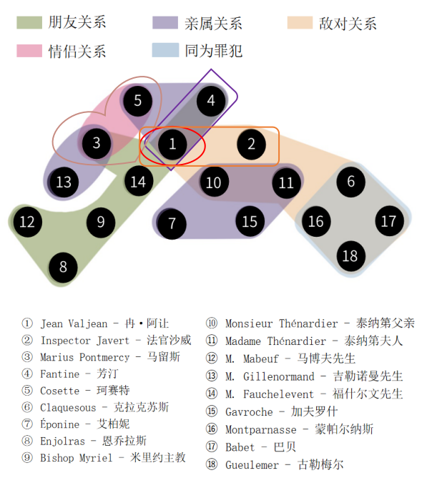

1. **the factors of interest in the experiment**

3.1 Concavity--Experiment 1

Convexity refers to the degree of non-convexity of each hyperedge in a hypergraph. A hypergraph with lower convexity (i.e., less non-convexity) will be more visually appealing. In the image shown below as Figure 1, the hyperedge on the right has lower non-convexity and thus lower convexity compared to the left one, resulting in a more aesthetically pleasing hypergraph.

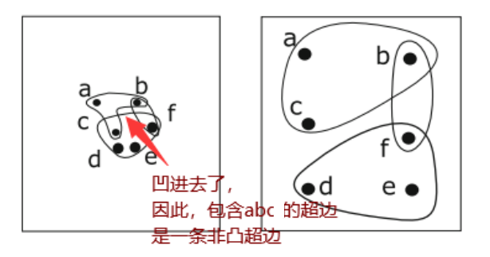

Figure 1

Notice: When answering questions, users should focus on the convexity of each hyperedge rather than the overall shape. In the image shown below as Figure 2, the overall shape is approximately circular with low convexity, but each edge within it has high convexity.

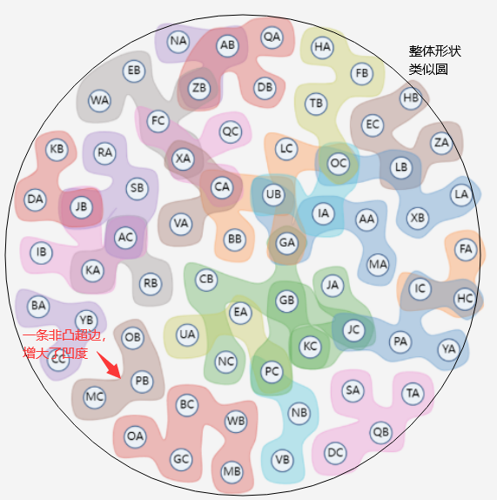

Figure 2

Hint: During the experimental process, you may encounter situations where the convexity of hyperedges is similar, making it difficult for you to rank them accurately. In this case, there is no need to be extremely precise in sorting, as what we value most is often the results at the top and bottom of the ranking.

3.2 Flatness--Experiment 2

Planarity refers to the number of intersections between hyperedges. The lower the planarity, the more favorable it is to avoid clutter and thus prevent ambiguity in the relationships represented by the hypergraph.

Notice: In the image shown below as Figure 3, consider the red box. The green hyperedge covering the pink one does not count as an intersection because this relationship is defined by the dataset, not something that can be changed through the layout algorithm. Regarding the black box, there are multiple hyperedges converging at the point "NORA", but this also does not count as an intersection.However, in the purple box, the overlapping regions between the green and brown hyperedges do count as intersections, and this is not one of the previous cases described.

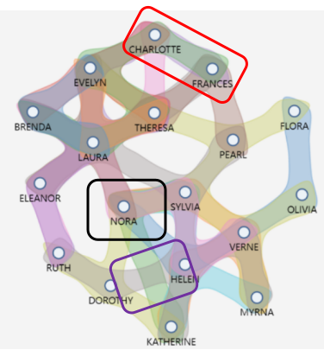

图3

3.2 Flatness--Experiment 3

Coverage refers to the utilization of the canvas by the hypergraph. It indicates how well the hypergraph utilizes the available space on the canvas.

Notice: The blank space within the hypergraph also counts as utilization of the canvas. In the image shown below as Figure 4, the gap between DB and LC inside the red circle still counts as utilizing the canvas (since we consider it as being caused by the repulsive force of the layout algorithm).

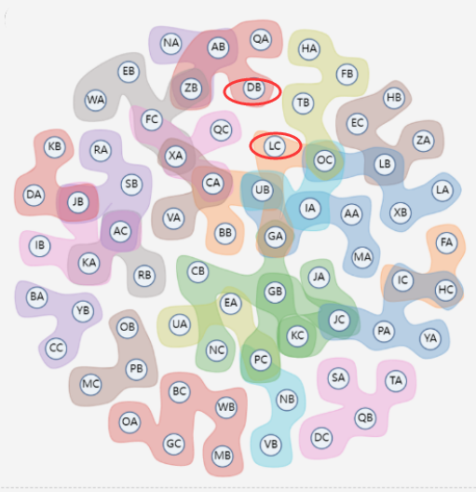

Figure 4

3.3 Distance between nodes--Experiment 4

Node-to-node edge distance: Its uniformity mainly depends on whether the edge lengths between nodes are evenly distributed.

Notice: Please note that what we are investigating is the connection distance, not the node distance. As shown in Figure 5, the node distance is relatively uniform because the distance between each pair of nodes is similar, such as the distance between node MC and its neighbors PA and HC. However, the uniformity of the connection distance between nodes is low because the brown edge connecting nodes MC and OB in the red box is extremely long (note that PA, SA, and TA are not part of the brown hyperedge).

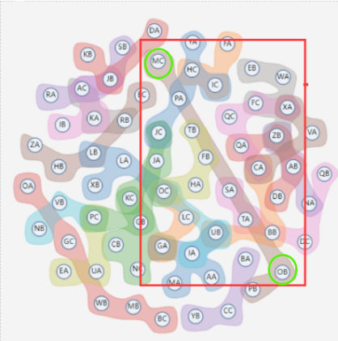

Figure 5

3.4 The bility to recognize data categories--Experiment 5

We will ask the user to determine whether the two points are in the same class based on the specific questions listed.

Notice: Since the second and third data sets have more points, the two points we explored, "LB" and "XB", are marked with blue and blue boxes, as shown in Figure 6 below.

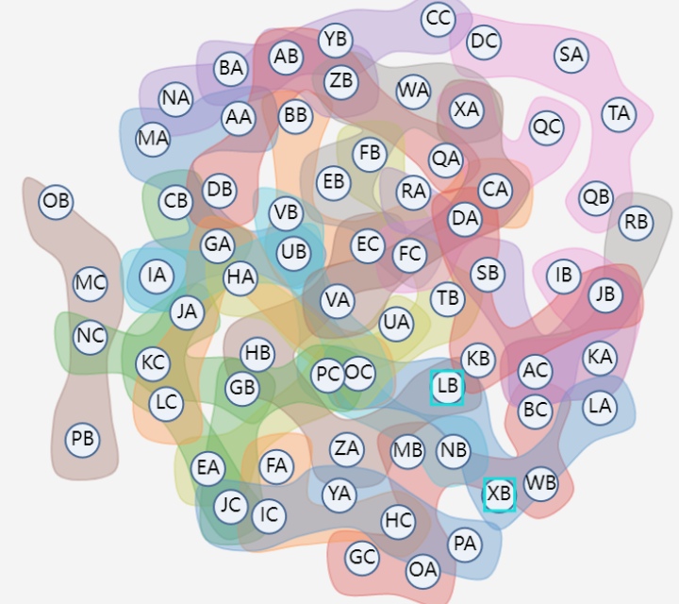

Figure 6